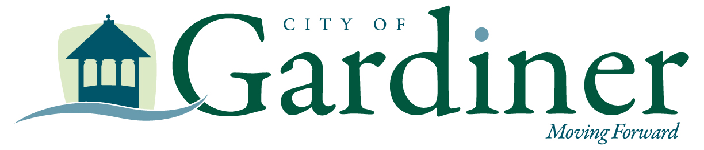

GARDINER CITY COUNCIL MEETING AGENDA
GARDINER CITY COUNCIL CHAMBERS
DECEMBER 3, 2025
6:00PM PUBLIC MEETING

Meet & Greet City Manager Final Candidate from 6-6:30

The public is welcome to attend. Public meetings will be live streamed at:
https://www.gardinermaine.gov/livestream

- ROLL CALL / PLEDGE OF ALLEGIANCE

- PUBLIC COMMENT (anything not on the Agenda) (ALL PUBLIC COMMENT MUST BE SENT VIA EMAIL TO DBROWN@GARDINERMAINE.COM, REGULAR MAIL: 6 CHURCH STREET GARDINER ME 04345 OR CALL 207-582-4200 DURING REGULAR BUSINESS HOURS. A REQUEST TO SPEAK IN-PERSON DURING THE MEETING WILL ALSO BE RECOGNIZED).
- PETITIONS / PUBLIC HEARINGS PETITIONS / PUBLIC HEARINGS (ALL CORRESPONDENCE REGARDING THESE PUBLIC HEARINGS MUST BE SENT VIA EMAIL TO DBROWN@GARDINERMAINE.COM, REGULAR MAIL: 6 CHURCH STREET GARDINER ME 04345 OR CALL 207-582-4200 DURING REGULAR BUSINESS HOURS)
  - Public Hearing regarding a Liquor License Renewal for Canton Village
  - Public Hearing regarding a Liquor License Renewal for The Bench

- NEW BUSINESS
  - Mayoral Proclamation declaring Friday, December 5th Shop Small Day in Gardiner
  - Mayoral Proclamation for Mark Duchette the Grand Marshal for the Parade of Lights
  - Consideration of approval regarding a Liquor License Renewal for Canton Village
  - Consideration of approval regarding Liquor License Renewal for The Bench
  - Consideration of disposition of City owned property on Marston Road
  - Consideration of accepting the City Council meeting minutes from 11/3/25, 11/5/2025, and 11/19/25
  - Approval of the regular meeting dates for 2026 for the Gardiner City Council

- DEPARTMENT HEAD REPORTS – October
- INTERIM CITY MANAGER REPORT
- COUNCIL REPORT/COMMITTEE UPDATES
- EXECUTIVE SESSION
  - Executive Session pursuant to 1 M.R.S.A. 405(6)(C): Regarding Real Estate Matter
  - Executive Session pursuant to 1 M.R.S.A. 405(6)(A): Regarding Personnel Matter

- ADJOURN
____________________________________________________

Public Participation Expectations
- Verbally clarify for the public:
              - That their input is encouraged regardless of what others say.
              - What topics are appropriate at what times in the meeting.
              - That public input is not a time for discussion with Council members. Don’t expect an immediate response.
              - Public comments should not be more than 4 minutes and should not be repetitive.
- Provide Guidelines for Speakers on the back of every Council Meeting Agenda.
- Council members should show gratitude and validation of public comments and ask clarifying questions but not respond or engage in discussion with the public during a Council Meeting.

Upcoming Meeting Dates

December 17, 2025

